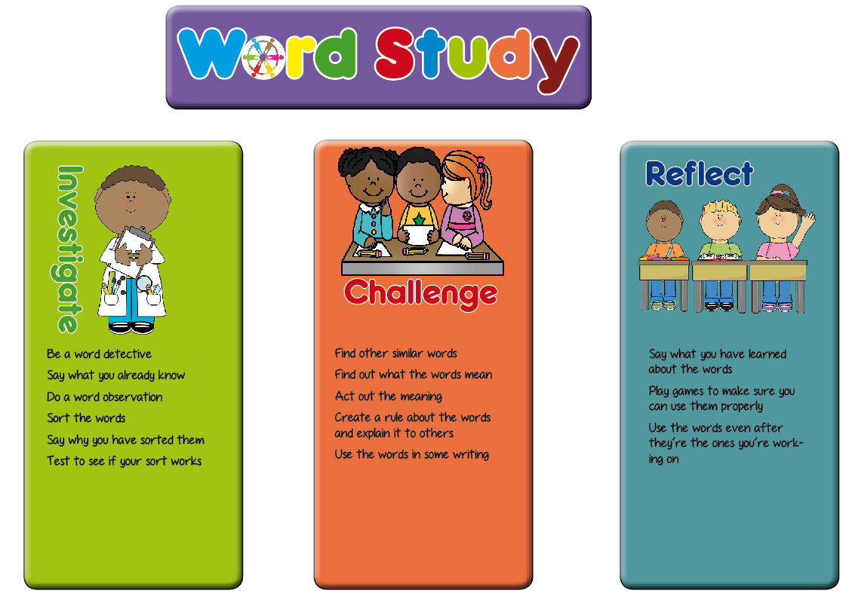**Year 1 Planning Ideas**

In Key Stage One, we have planned a range of generic activities which fit in with the word study teaching sequence. These are a suggestion for ideas which will generate talk for spelling activities and promote enquiry and discussion of the way words work among the pupils.

Hopefully these ideas will be a springboard for the activities you plan in your classroom.

|  |  |  |
| --- | --- | --- |
| **Investigate** | **Challenge** | **Reflect** |
| * Say what they know about the words (modelling) * Soundtalk the words * How many phonemes are there in the word? * Are there long or short vowels in the word? * How many syllables are there in the word? * Look for small words in the whole words * Look at the shape of the words * Look at what the words mean * Do a word sort (see the word sort resources section of the web site) * Say why they have sorted the words in the way they have * Explain what they think the spelling rule sort is | * Explain to someone else how to do the word sort * Finger spy or magnifying glasses to find words that are similar (visit other classes, stuck around the room, in the garden, in their reading books) * Find out what the new words mean (using dictionaries, ask someone at home) * Can you act the words out? * Explain how to use the words * Can you put the words in a sentence? * Can you find other words with the same pattern to add to your word sort? | * Play hangman with the words * Play bingo with words * Play snap with words * Build with magnetic letters (could be timed) * In pairs, take turns to spell the words * Spelling investigation writing – use different colours * Have a poster area for children to add words to the word sort as they find them in their reading |